**Database model**

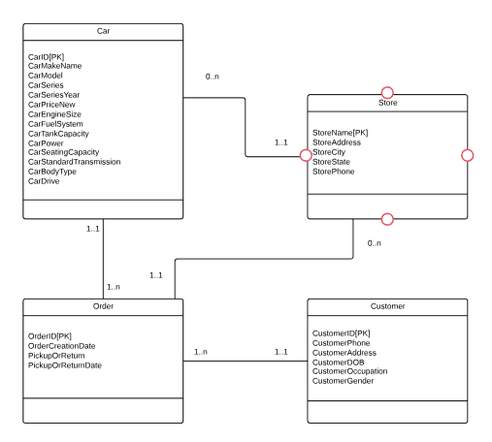

**Test Data**

**Customers**

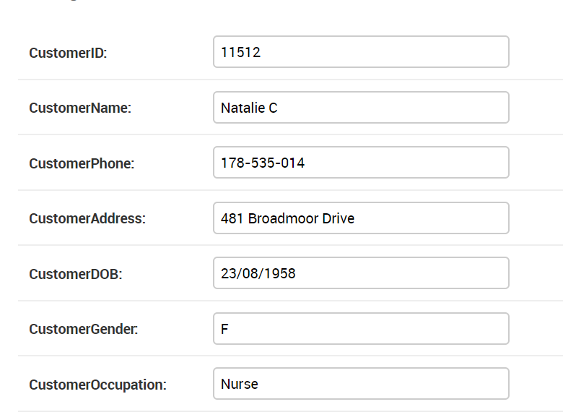

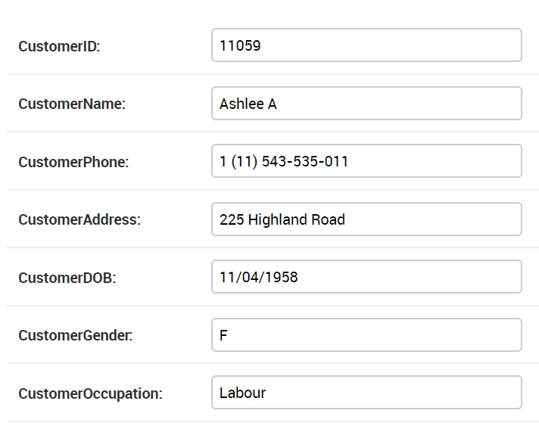

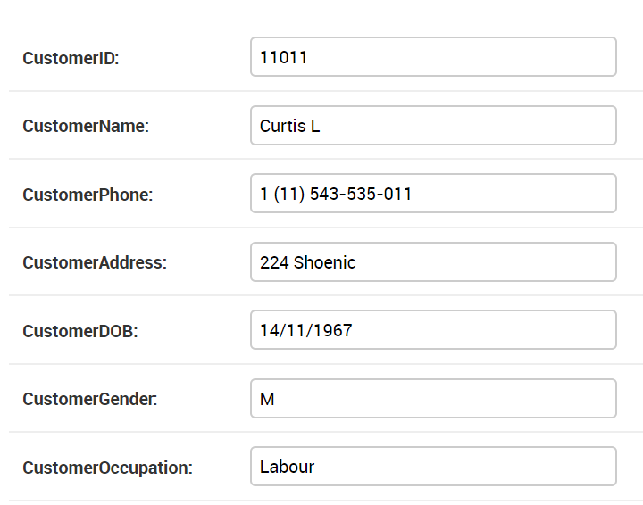

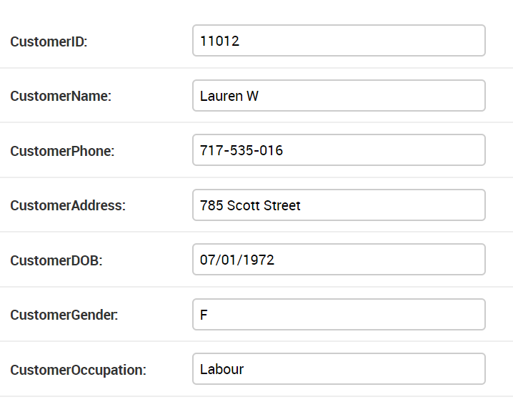

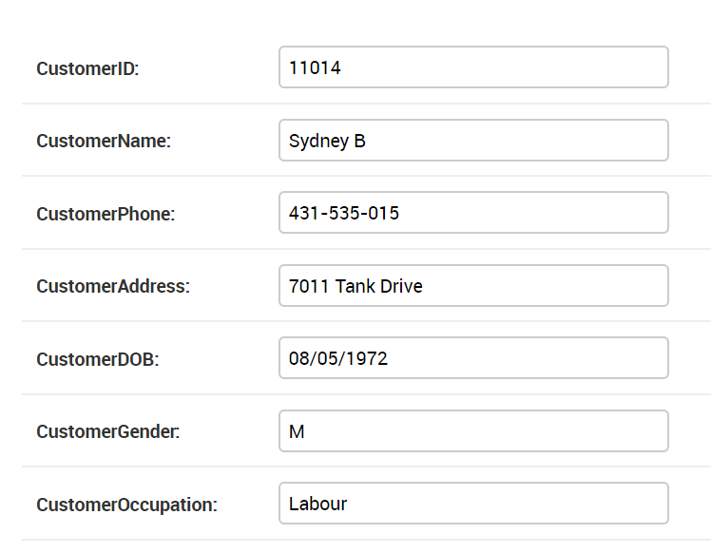

**Rental history**

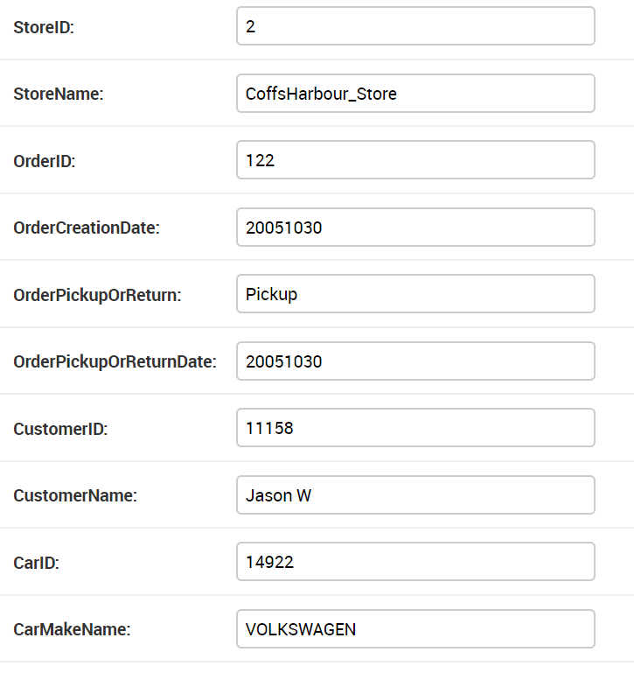

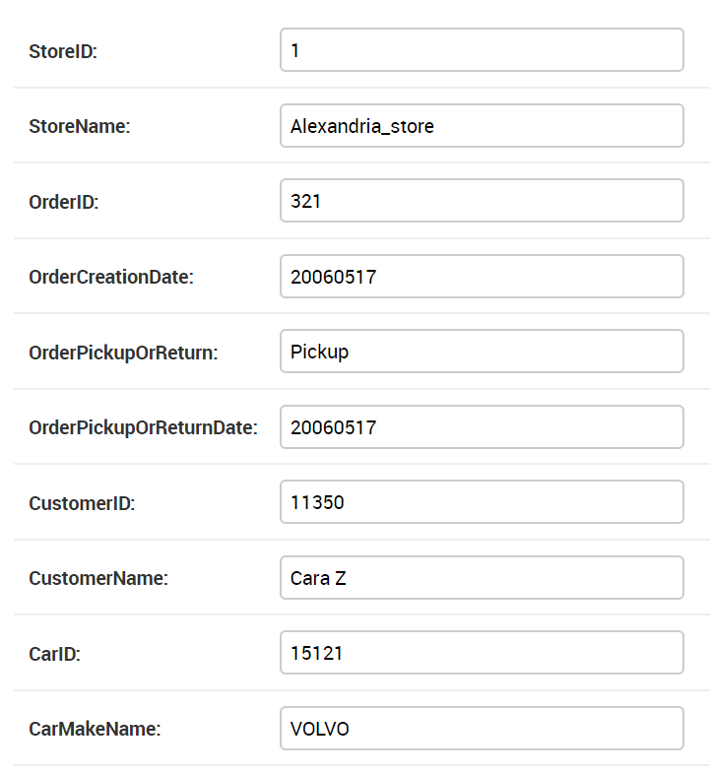

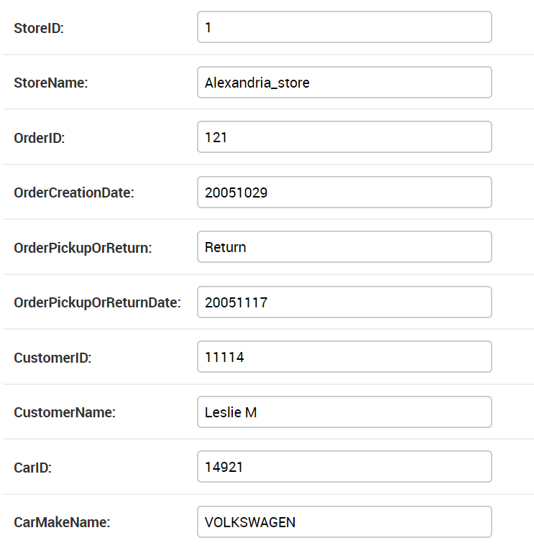

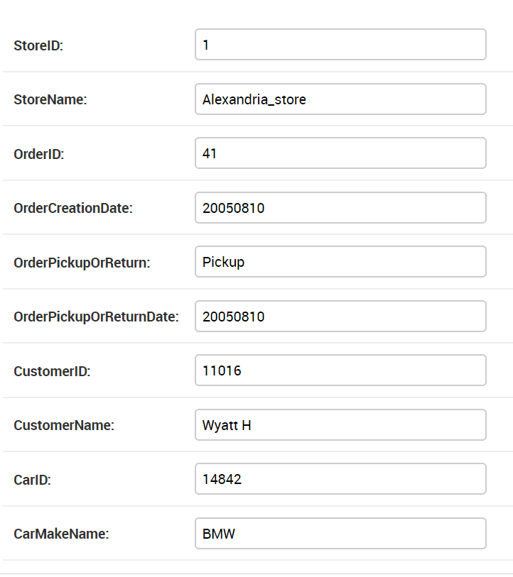

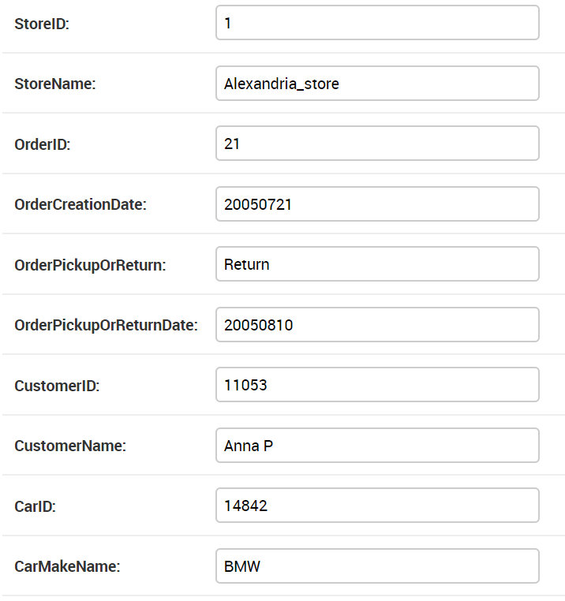

**Rental Trends**

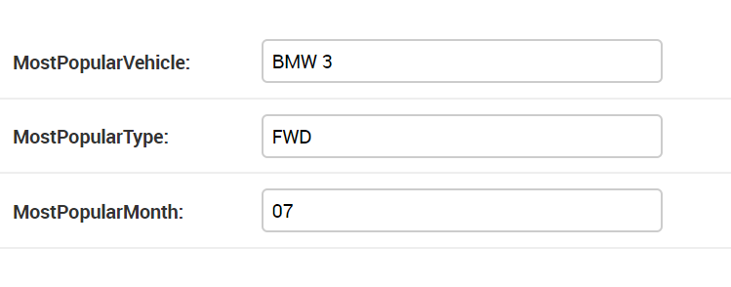

**Store Trends**

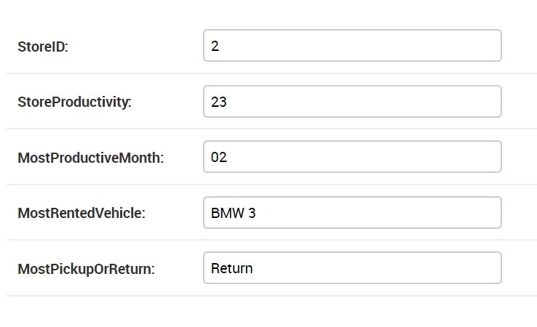

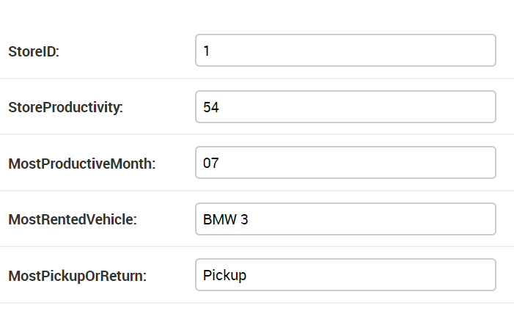

**Users**

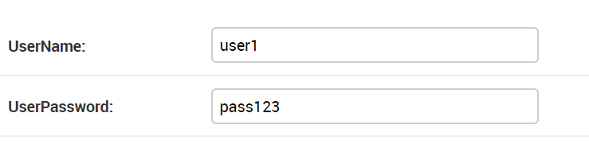

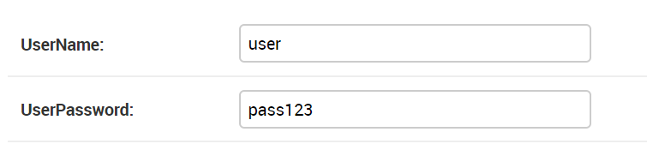

**Vehicle List**

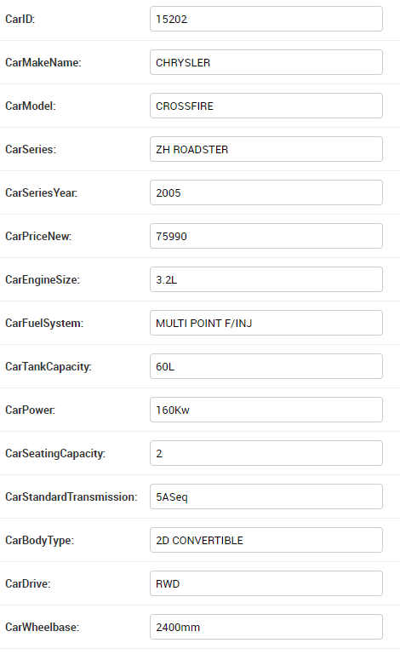

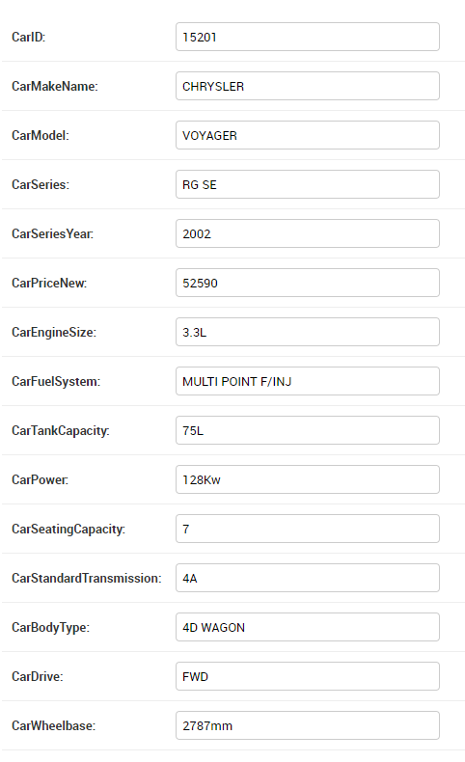

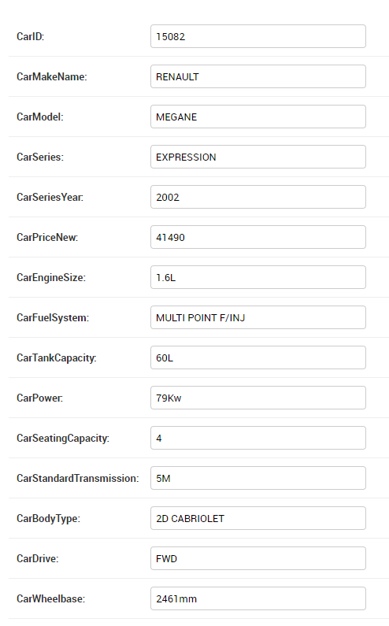

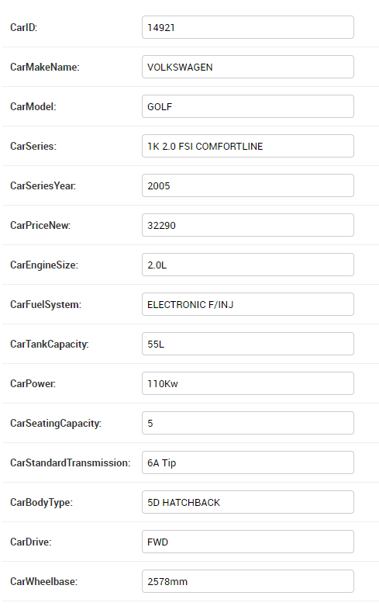

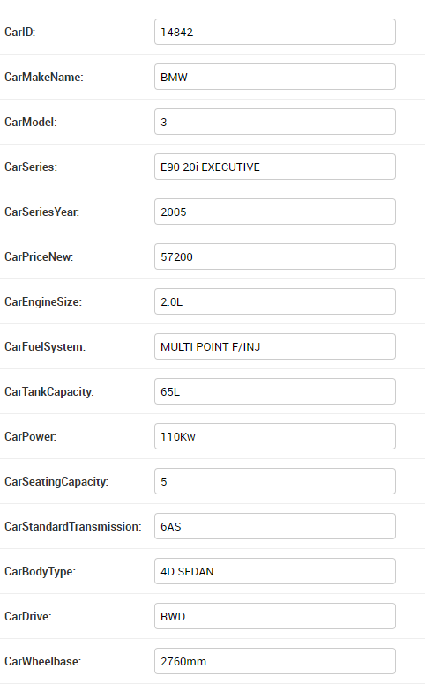

**SQL database creation commands**

CREATE DATABASE *MotorSpecs;*

CREATE TABLE Customer (

CustomerID int,

CustomerName varchar(255),

CustomerPhone int(10),

CustomerAddress varchar(255),

CustomerDOB date(),

CustomerOccupation varchar(255),

CustomerGender varchar(255)

PRIMARY KEY (CustomerID)

);

CREATE TABLE Store (

StoreName varchar(255),

StoreAddress varchar(255),

StorePhoneNumber int(10),

StoreCity varchar(255),

StoreState varchar(255)

PRIMARY KEY (StoreName)

);

CREATE TABLE Car (

CarID int,

CarMakeName varchar(255),

CarModel varchar(255),

CarSeries varchar(255),

CarSeriesYear varchar(255),

CarPriceNew varchar(255),

CarEngineSize varchar(255),

CarFuelSystem varchar(255),

CarTankCapacity varchar(255),

CarPower varchar(255),

CarSeatingCapacity varchar(255),

CarStandardTransmission varchar(255),

CarBodyType varchar(255),

CarDrive varchar(255)

PRIMARY KEY (CarID)

);

CREATE TABLE Order (

OrderID int,

OrderCreationDate date(),

PickupOrReturn varchar(255),

PickupOrReturnDate date(255)

PRIMARY KEY (OrderID)

);